**User’s Manual**

1. Software requirements

①Java version 1.8 or newer

②Matlab R2017b or MCR

1. Installation of the FogWorkflowSim

①Go to the repository page ([https://github.com/FogWorkflowSim/FogWorkflowSim-1.0](https://github.com/WorkflowSim/WorkflowSim-1.0)) and click ‘Clone or download’;

②Choose ‘Download ZIP’ and then unzip it;

③Copy ‘FogWorkflowSim’ folder to your eclipse’s workspace;

④Open your eclipse and create a java project called ‘FogWorkflowSim’.

1. Running of the FogWorkflowSim

For convenience, we use the figures marked with numbers below to show how to run the system.

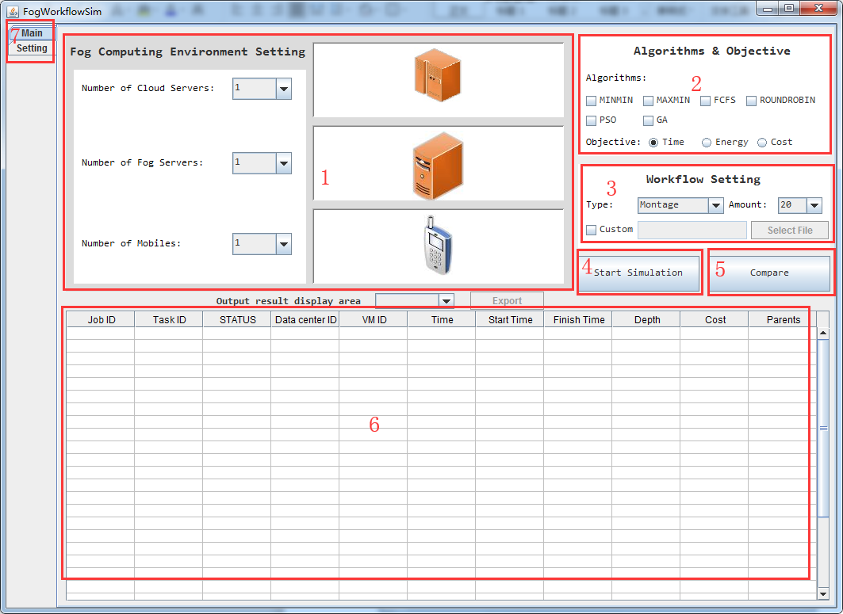

Figure 1: The Main Interface of Simulation Tool

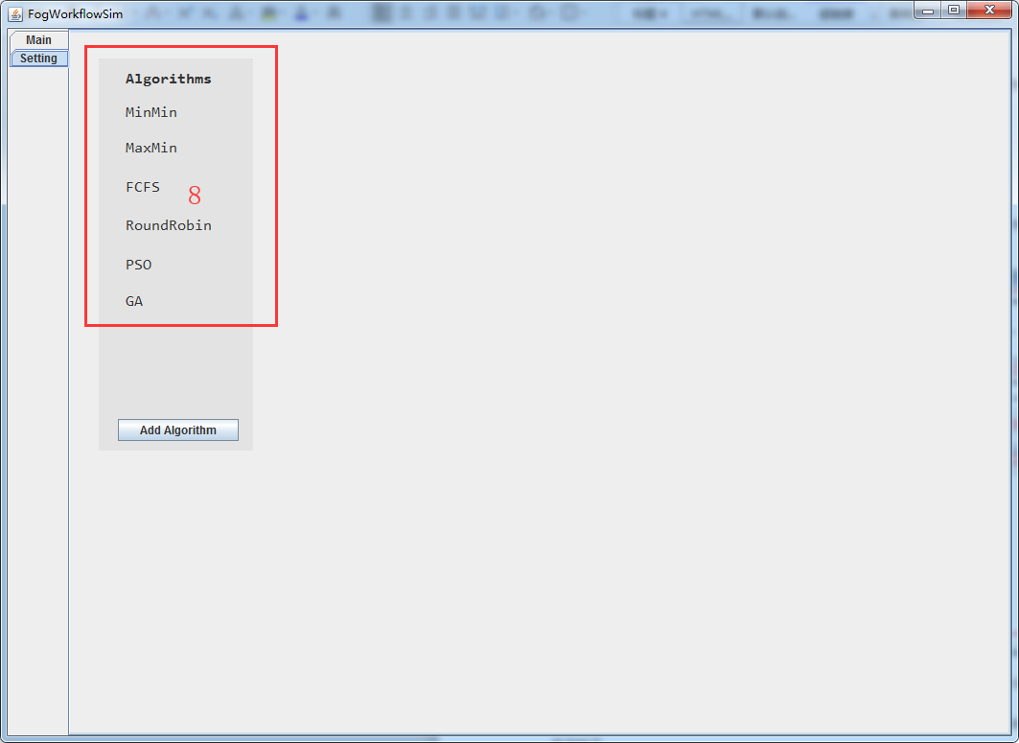

Figure 2: The Algorithm Interface of Simulation Tool

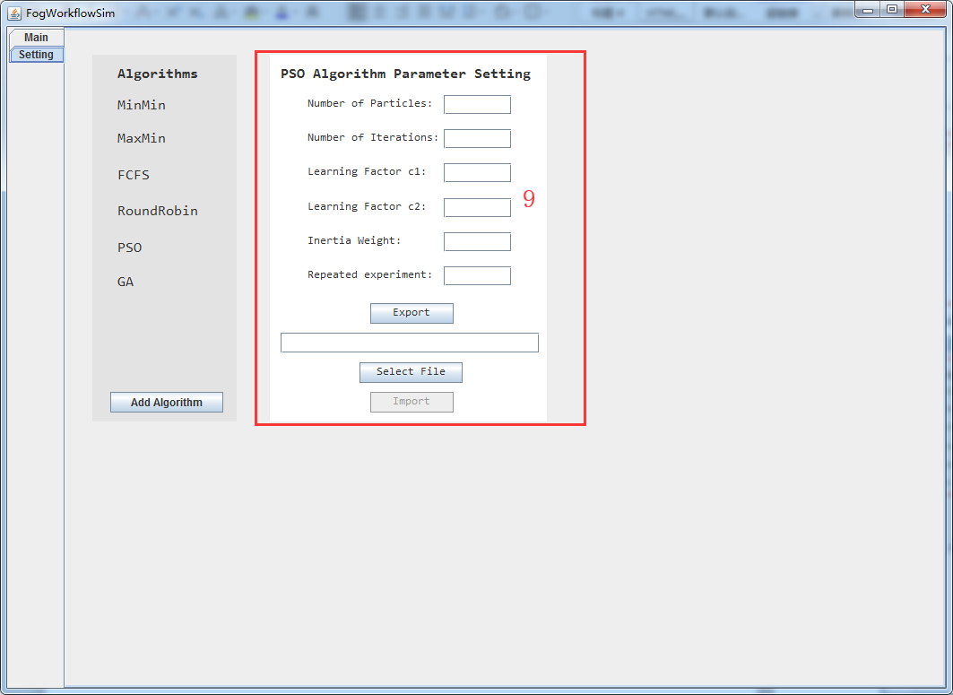

Figure 3: The Algorithm Parameter Setting Interface of Simulation Tool

①Open the project to find ‘UI.java’under org.fog.test.perfeval, and then click ‘Run’;

②Choose the number of Cloud Server, Fog Server and Mobile in box 1;

③Choose algorithm(s) you want to use or compare and algorithm’s optimization objective in box 2;

④Choose the workflow that comes with the system or the customized one in box 3;

⑤If you have chosen an or several intelligent algorithm(s) in step ③,you need to set parameters for your algorithm(s).

The process of setting parameters is as follows:

(1) Click ‘setting’ in box 7;

(2) Choose the algorithm(s) in box 8;

(3) Edit parameters for algorithm(s) or click ‘Select File’ to choose file and then click ‘Import’ in box 9.

⑥If you have chosen only one algorithm in step ③, click ‘Start Simulation’ in box 4; Otherwise, click ‘Compare’ in box 5.